

**Volunteering at Thrive Women’s Aid**

Thrive Women’s Aid is an established and well respected charity delivering support services for women, children, young people and families affected by domestic abuse. We consider ourselves to be a progressive and dynamic company that is at the forefront of our sector due to the high quality services delivered across our organisation.

Thrive is a friendly, supportive and rewarding environment and we know that our volunteers are key to the success and growth of our organisation. We value our volunteers by offering support, training, development and progression to enable everyone to reach their full potential.

**Current Opportunities**

Thrive have three exciting new volunteering roles available. Please see further information on each opportunity below.

**Project Administration Volunteer**

Your role will be to volunteer within our organisation to support the administration of our busy team of specialist support staff. You will welcome visitors to our office and assist the team to maintain a friendly, organised and efficient office environment. Your role will include answering the phone and taking messages, welcoming visitors, and completing administrative tasks such as filing and creating packs for service delivery. You will also assist with inputting information on our IT systems and support us to collect service monitoring feedback.

**Group Work Volunteer**

Your role will be to volunteer within our adult and/or children and young person survivor groups, providing facilitation assistance to our team of specialist support staff. You will work alongside us at a variety of community venues during training, meetings, and events; helping to set up venues and ensure things run smoothly. The role includes stocking refreshment areas, making drinks, preparing resources and chatting with attendees to help them to feel at ease.

**Activities Volunteer**

This volunteering opportunity is specifically for individuals who have skills they would like to share. Whether your skill is in a specific craft, activity, exercise or hobby, your role will be to demonstrate and teach new activities at a variety of community venues to groups of adults and/or children and young people who are survivors.

**What will be expected of me?**

* You will have a good, non-judgemental, understanding of domestic abuse and the impact it has on individuals and families and we will provide training to enhance your knowledge.
* Your time commitment will be flexible and agreed between Volunteers and the Volunteer Manager.
* You will ensure that any safeguarding concerns and relevant information is shared appropriately within the organisation and in line with GDPR confidentiality procedures.

**What personal qualities do I need to volunteer with Thrive?**

* Friendly and approachable nature.
* Good communication skills and the ability to make people feel comfortable.
* Good time-keeping and reliability.

**Benefits**

* Training opportunities.
* Expenses.
* Work experience and future references.

**Things you need to know**

* A disclosure and barring security check is required for this role.
* Volunteers will be based at Thrive WA Head office or other community venues.
* Some, but not all, volunteering posts are exempt under the Sex Discrimination Act Section 7(2)(e) and open to women only.
* All applications will be assessed on a case by case basis.
* We will not automatically exclude applicants with an offending background, however in the interest of your safety and the safety of others, some roles will require disclosure of offending.
* We encourage those with lived experience of domestic abuse to apply. For the safety and wellbeing of you and our service users we stipulate that all volunteers must have ceased being supported by a domestic abuse organisation for at least 6 months before applying.

**Volunteering for Thrive**

**Vision**

Our Vision is to create safe communities, free from domestic abuse where people and families can flourish and build successful independent lives.

**Mission**

To be an innovative and sustainable provider of excellent, good value domestic abuse services that drive prevention, provide interventions and enable progression.

Please click to view our [Impact Report](https://thrivewomensaid.org.uk/our-impact/) and [Strategic Plan](https://thrivewomensaid.org.uk/about/#strategicplan).

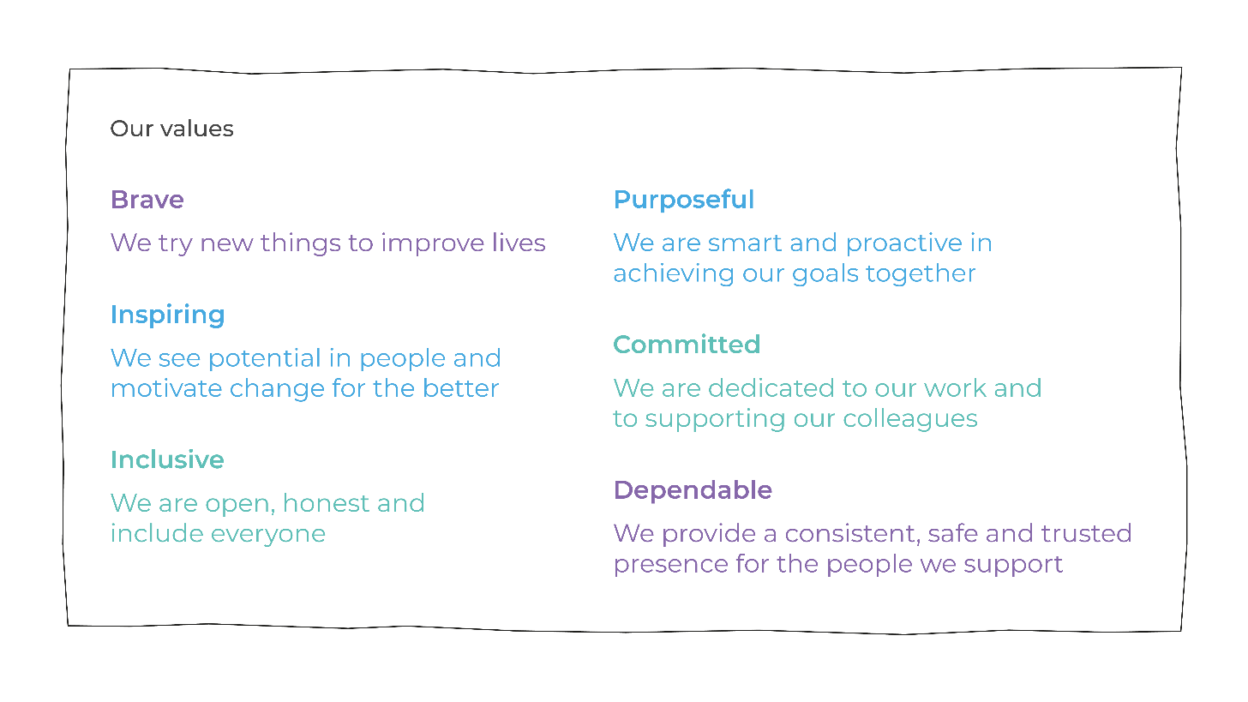

**Application and further information**

**To apply**

Please complete an application form which can be downloaded from our website <https://thrivewomensaid.org.uk/get-involved/i-want-to-volunteer/>.

**Contact point for applications**

Antonia Devaney / [volunteering@thrivewa.org.uk](mailto:volunteering@thrivewa.org.uk) / 01639 894864