

**Thrive Youth Board**

**Volunteering Opportunity for Children and Young People**

**Who are we?**

We are the **T**hrive Youth Board (Thrive YB). We are group of young people who are **H**opeful about making change in our community. We are **R**evolutionary, **I**nspiring children and young people to make their **V**oices heard. We are an **E**ducational and awareness-raising group who want to share our knowledge in our community about domestic abuse and violence.

**Who can apply for Thrive YB?**

* People aged 11 to 21 who are:
  + Passionate about becoming a leading voice against gendered based violence
  + Open to learning new things and meeting new people
  + Passionate about raising awareness in your community and making a change

**What do Thrive YB members do?**

* Attend regular meetings
* Undertake awareness training
* Campaign and fundraise
* Attend youth conferences
* Have the opportunity to attend Thrive’s organisational meetings
* Use their voices to influence change in community response to domestic abuse and shape children’s domestic abuse services

**What are the benefits?**

* Working to end VAWDSV
* Potential hours towards Welsh Baccalaureate
* Gain valuable skills
* CV enriching experience
* Tempo Time Credits
* Having your voice heard
* Meet new people
* Becoming a leader in your community
* Potential UCAS references
* Creative work
* Having fun!

Does this sound like something you would like to be a part of? **Applications are now open!**

**Volunteering for Thrive**

**Vision**

Our Vision is to create safe communities, free from domestic abuse where people and families can flourish and build successful independent lives.

**Mission**

To be an innovative and sustainable provider of excellent, good value domestic abuse services that drive prevention, provide interventions and enable progression.

Please click to view our [Impact Report](https://thrivewomensaid.org.uk/our-impact/) and [Strategic Plan](https://thrivewomensaid.org.uk/about/#strategicplan).

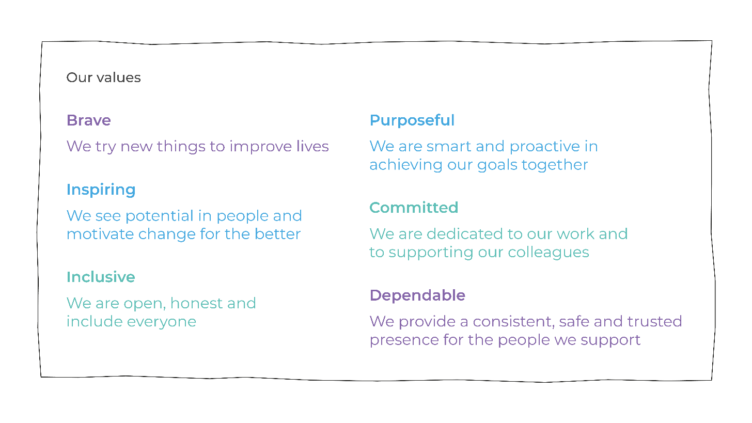

**Things you need to know**

* Consent must be given by a caregiver if you are under the age of 16.
* A disclosure and barring security check is required for this role (for those who are 16 and over).
* Volunteers will be based at Thrive WA Head office or other community venues.
* Some, but not all, volunteering posts are exempt under the Sex Discrimination Act Section 7(2)(e) and open to women only.
* All applications will be assessed on a case by case basis.
* We will not automatically exclude applicants with an offending background, however in the interest of your safety and the safety of others, some roles will require disclosure of offending.
* We encourage those with lived experience of domestic abuse to apply. For the safety and wellbeing of you and our service users we stipulate that all volunteers must have ceased being supported by a domestic abuse organisation for at least 6 months before applying.

**Application and further information**

Applications are now open! To apply please complete the following form and either email it to:

Antonia Devaney at [volunteering@thrivewa.org.uk](mailto:volunteering@thrivewa.org.uk)

Or post it to:

FAO Antonia Devaney, Thrive Women’s Aid

PO Box 20

Port Talbot

SA13 1DN

**Contact point for applications**

Antonia Devaney / [volunteering@thrivewa.org.uk](mailto:volunteering@thrivewa.org.uk) / 01639 894864

Matthew Wilson / [mattheww@thrivewa.org.uk](mailto:mattheww@thrivewa.org.uk) / 01639 894864

[www.thrivewomensaid.org.uk](http://www.thrivewomensaid.org.uk)

Funded by:

**Tips for Completing a Thrive Youth Board Application**

**The basics**

Make sure you complete all of the sections, without missing any information.

Ensure you get consent from you parent/care giver if you are under the age of 16.

**All about you!**

Tell us about yourself, and why you would like to apply for Thrive YB. The more detail the better – we want to know YOU!

You can write about your favourite subjects in school, what your hobbies are, or who your role model is. There is no right or wrong answers; we just want to read about who you are as a unique individual!

**Lived experience**

We welcome applications from people who have experience domestic abuse, but we suggest that you have not received any support for six months before you apply. Our team at Thrive are always here to help and support you, but we want you to feel ready to discuss domestic abuse in a safe environment. We will never ask you to discuss your personal experience within the group, unless you would like to.

The aim and vision of Thrive’s Youth Board is to have a community voice to help shape our services and to make a change in the local area, i.e. schools, colleges, and community youth clubs etc. Your experiences, your opinions, and your voice matters!

**Contact point**

Our volunteering packs always contains a contact point for further information. If you want to find out more about the role or check your suitability please use the contact information provided.

**Road Map to Volunteering**

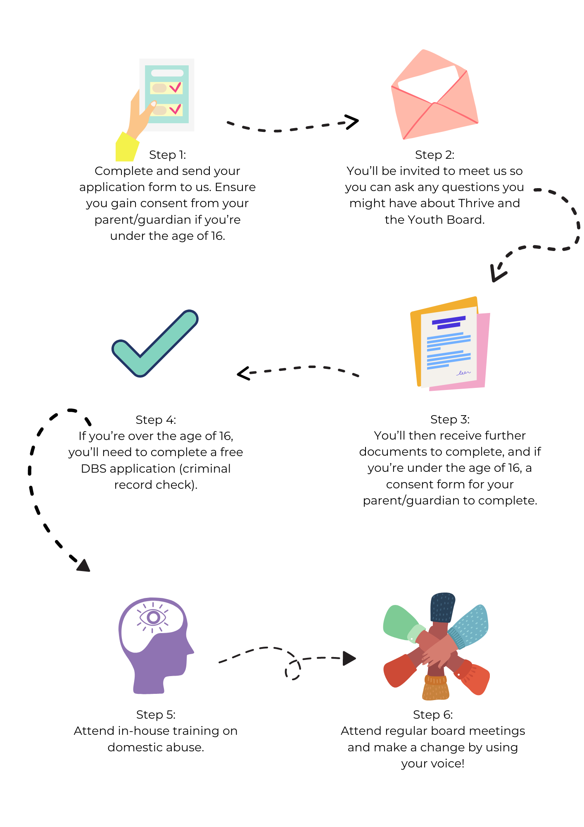

**Thrive Youth Board**

**Application Form**

|  |  |
| --- | --- |
| Name |  |
| Date of Birth |  |
| Primary address |  |
| Email address |  |
| Phone number |  |
| School/ college name |  |
| Year group |  |
| Name of head of Year |  |
| Do you have any knowledge or experience of domestic abuse | Yes / No |
| Please tell us a little about yourself; i.e. your hobbies, favourite subject in school etc. |  |
| Why do you want to be part of our exciting Youth Board? |  |
| Signature |  |

|  |
| --- |
| **Rehabilitation of Offenders Act 1974:** |
| **We may obtain information from the Disclosing & Barring Scheme (DBS) following recruitment as a volunteer.**  **Do you have any unspent convictions? YES / NO**  (please provide details)  **Are you aware of any convictions that would prevent you from working with vulnerable adults or children? YES / NO**  (please provide details) |

|  |  |  |  |
| --- | --- | --- | --- |
| **Declaration (to be completed by care giver if under 16 years old):** | | | |
| *In accordance with the 1998 Data Protection Act, I agree that include may hold and use personal information about me for volunteering reasons and to keep in touch with me. This information, including that contained in this form, can be stored on both manual and computer files.*  *It will be held* ***securely*** *and* ***only*** *accessed by authorised personnel.* | | | |
| Signature: |  | Date: |  |

**Parent/ Guardian Details**

|  |  |
| --- | --- |
| Name |  |
| Relationship to CYP |  |
| Address |  |
| Email address |  |
| Phone number |  |
| Are you currently receiving support from Thrive WA?  Have you previously received support from Thrive WA? | YES/ NO  YES/ NO |
| Signature |  |